Week 7 - Beat the Clock

You guys are getting pretty good at creating Scratch programs so instead of walking you through the steps to build this game, I’m just going to show you the different parts that you can put together.

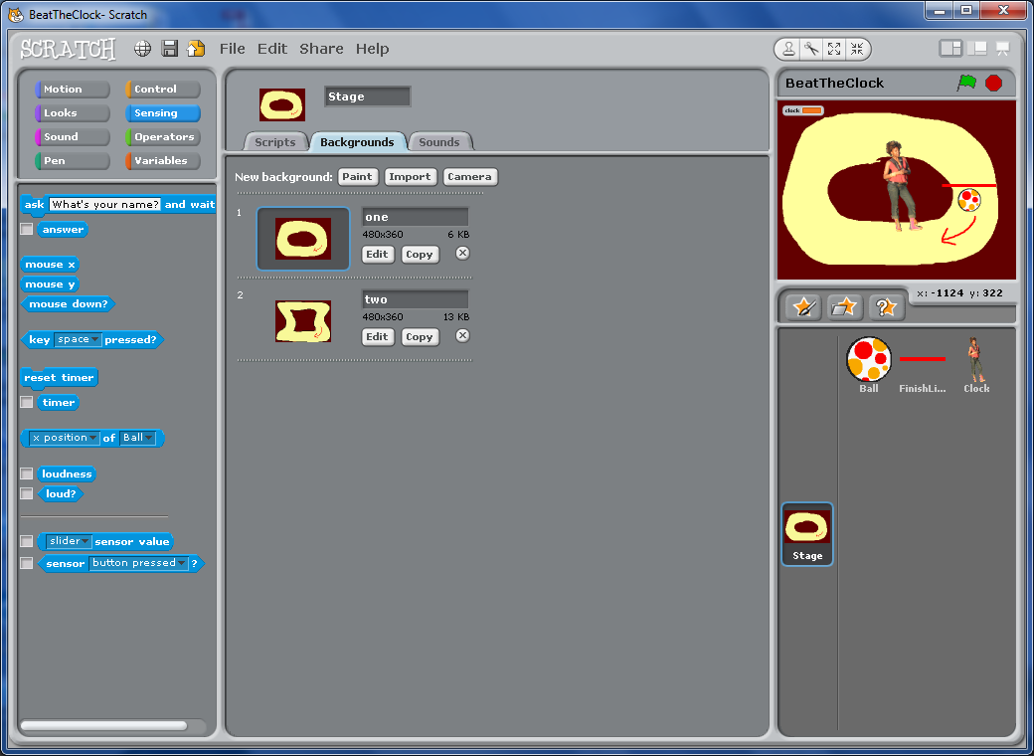The Stage:

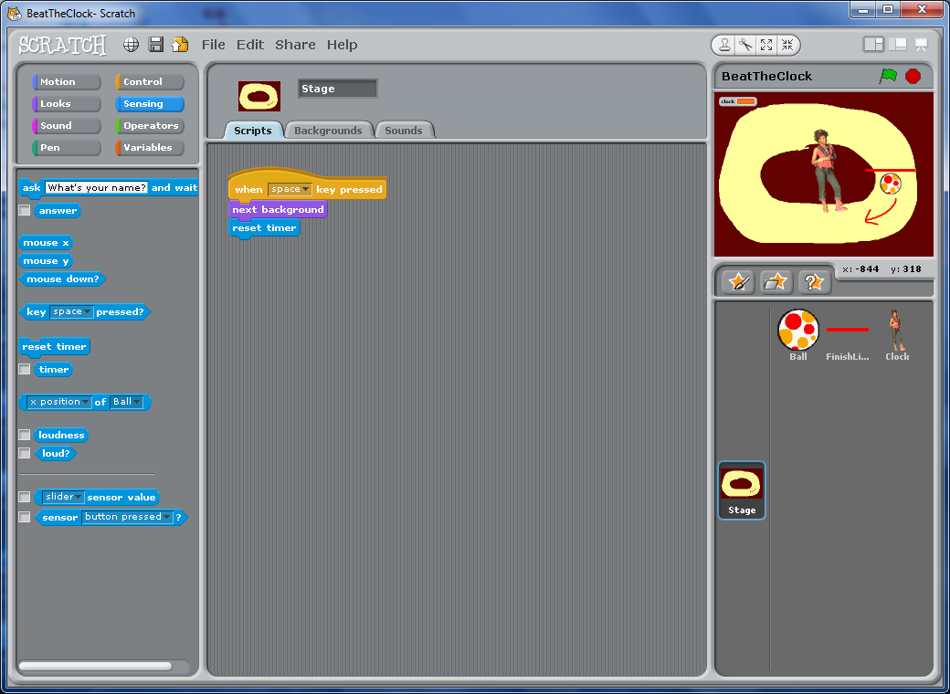For the stage, I created two different loops for the ball. Be sure to use the same background color to make keeping the ball on the track easier. You can create as many backgrounds as you like.

I added a simple script for the stage as well so that it is easy to move between the two backgrounds.

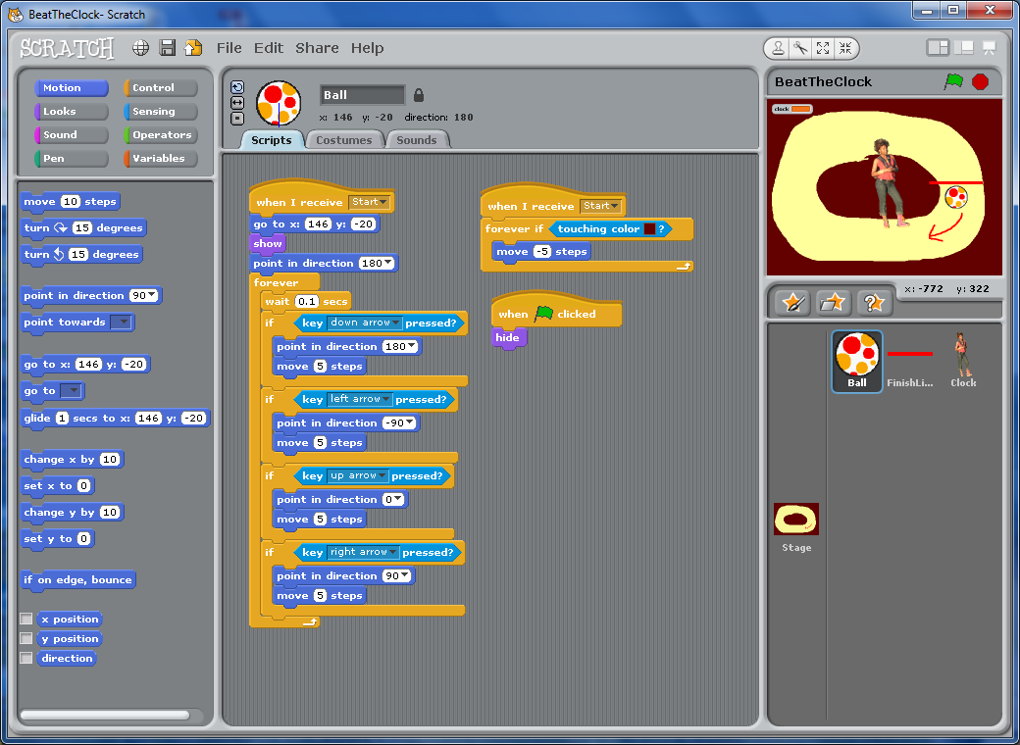The Ball:

The ball looks a lot like stuff we have done before. The big difference is the way I used events. Every time the ball gets a *Start* event, it resets itself.

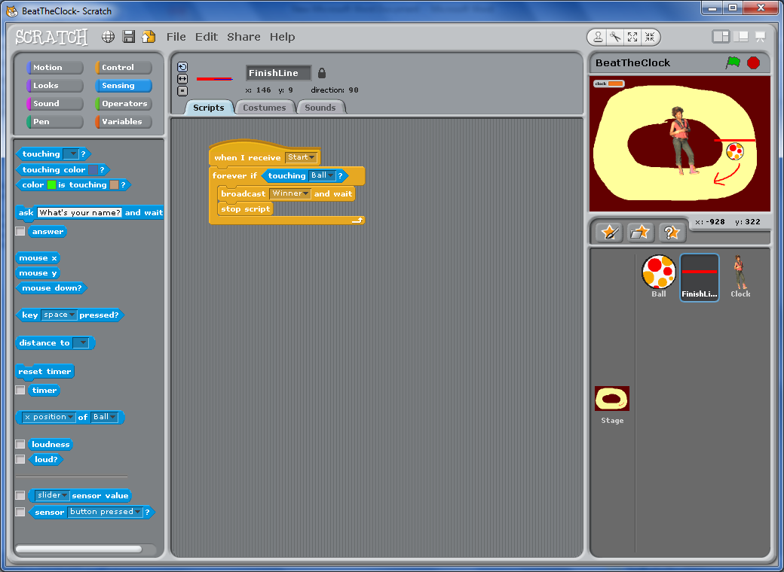The finish line:

You can use pretty much anything you want as the finish line. I used a simple line and have it announce when you win the game.

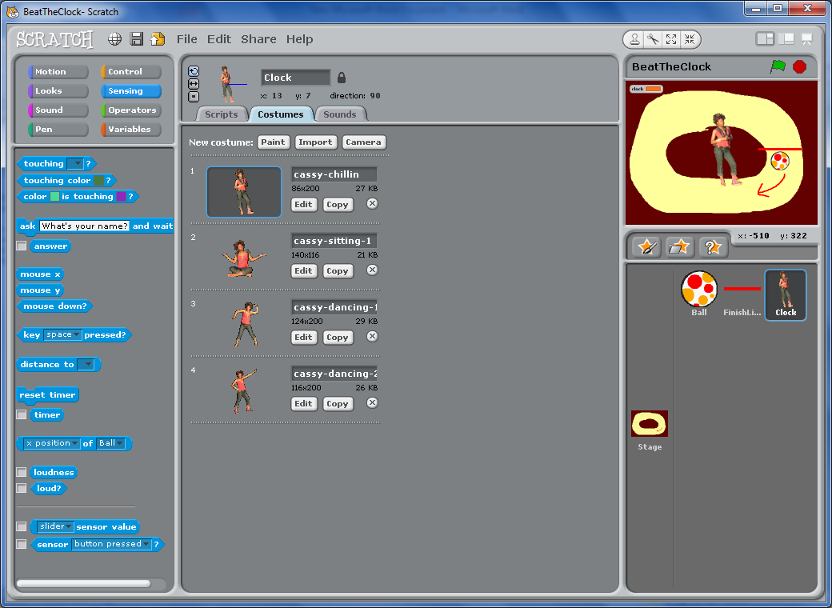The Clock:

This is the most interesting part of the game. I used 4 costumes (right) that you can find in the costume area. The first (Cassy-chillin) is used at the start and while you play the game. Cassy-sitting-1 is used when you lose and the last two dancing Cassys are used when you win.

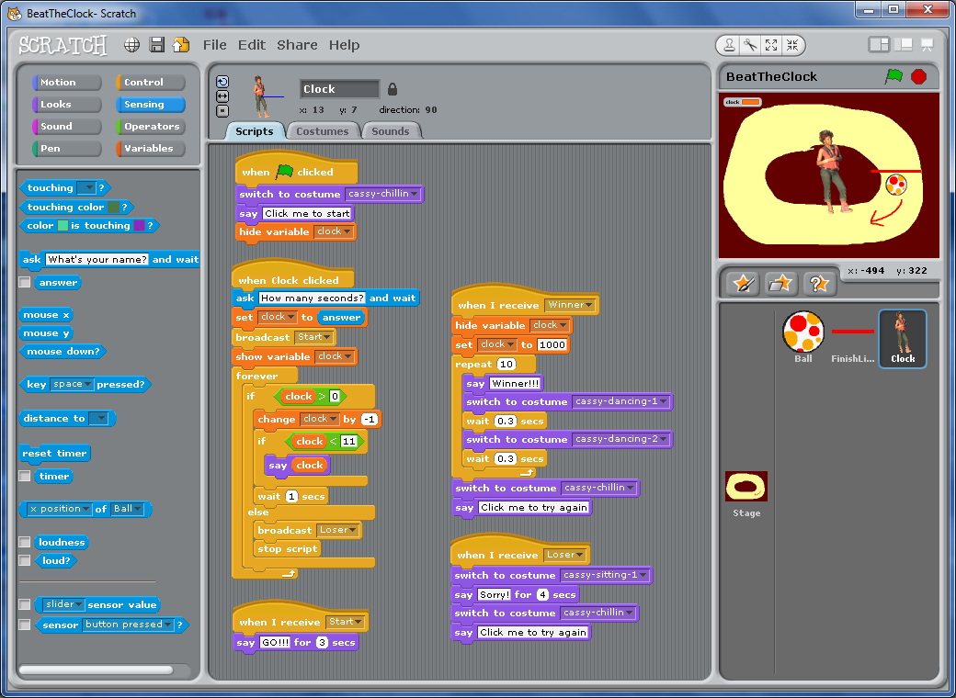There are five scripts for the Clock. The first three (right) do the setup and ask how many seconds to put on the clock. They also determine when time has run out and announce a Loser. The last two scripts (below) deal with the Loser and Winner events – switching costumes and announcing the result.

Make your Maze Amazing

Last week we worked on a maze program. You can continue to work on this. Here are some suggestions for different things you can do:

1. Add a clock (like the ‘Beat the clock’ program) or a timer to see how long it takes to get through the maze. The timer is in the Sensing menu. Be sure to reset it periodically!
2. Make the monster eat one (or all) bananas when he touches Scratchie by changing the ‘bananas’ variable.
3. Add additional doors that disappear when you collect enough bananas.
4. Add levels that get more difficult. You can do this with additional mazes or can make the monster move faster. This is tricky to do correctly – you will want to add a ‘NewLevel’ event to handle these changes.